# RH Mantrailing (MT) B title information

# **General information[1]**

Dogs must be 20 months old to enter this test.

This section applies to all exercises at all levels, unless otherwise noted.

To attain the full title - IPO-R FL B – the dog-handler team must pass both the obedience-dexterity phase with at least 70 points (out of 100) and the scent work phase with at least 140 points (out of 200) one time. To be eligible to attempt the B, the team must have a minimum of two level A tests in the same scent discipline with a minimum total G (80%) rating. If the team fails one phase (obedience/dexterity or scent work) they must attempt the other phase unless they are excused. It is up to the judge and trial logistics which phase is attempted first. On a multi-day trial, the phases need not occur on the same day. The team need not attain a minimum score on any single obedience-dexterity exercise; that is, you can fail a single exercise and still pass if you earn enough points in other obedience-dexterity exercises.

Behavior of the dog handler (you)[DH]: The judge will consider your behavior, team work with the dog, and sportsmanship.

Behavior of the dog [D]: The judge will consider the dog’s joy to work, handling, responsiveness to commands, mobility, fitness, endurance and the overall picture. The dog should carry out the exercises happily and quickly.

Rewards: You may praise your dog briefly after an exercise ends. You are not allowed to carry or provide food or toys to the dog in either phase.

Heeling: During heeling, the dog should have a natural gait. The dog should be at your knee, and should be attentive, happy, close, and straight. When you stop, the dog should sit without an auditory or visual command, and be close and straight.

Auditory command [AC] and visual command [VC]: For the majority of exercises both an auditory and visual command are allowed. When both are allowed, you can choose to give just auditory or just visual. If you tell the judge in advance, you can use a whistle as an auditory command. Any visual or auditory command must be short. If you use both you must use them simultaneously. The name of the dog is considered an auditory command. If the dog requires a second command to execute an exercise or part of an exercise, the team will be penalized. If the dog does not execute the command after a third command, the exercise is terminated and you receive a 0. If the dog refuses to execute an apparatus or search an area, you will get a 0 for the exercise. You may not repeat an obstacle or area. You should pause 3 seconds between commands. Non-use of auditory or visual commands are not considered faulty.

Obstacles: Unless told differently from the judge, each dexterity obstacle begins set up in heel position two steps before the obstacle and ends beyond it.

You can choose any commands. They can be in any language, including a mix of languages.

# **Scent work**

Before the trail itself, the dog will perform an odour differentiation, described here. For the B level, four helpers will walk together about 20 steps then each walk 5 meters away from one another and stand with their backs to the dog-handler team. The judge will give the handler a scent article from one of the helpers. The handler scents his dog; once off leash and after given an auditory, visual command, or both, the dog indicates the matching helper by performing the announced alert (bark or indication).

At the end of the trail, the dog must alert on the trail layer. The options are

- bark at the trail layer

- indication (dog does a sit, stand, or down at the trail layer)

The dog must trail in a harness and on a line between 5 and 10 meters long. The dog may also wear a fur saver collar or a plain buckle or quick release collar. Parasite collars are allowed. A GPS collar or handheld to record the trail is allowed although the victim’s trail is not made known to you in advance.

The trail is 4,000 steps (approximately 2,000 m) with a minimum of four changes of direction, at least one change in terrain, and at least two street crossings. The ratio of urban area to open area should be 50/50.

The trail begins at a distinctive spot like a bus stop, in front of a store, etc. If the trail has not naturally been crossed by outsiders, the judge will direct someone to cross the trail.

The trail is aged six hours. The trail layer can remain at the end or can be picked up in a closed vehicle. After laying the trail the trail layer may not approach the trail within 2.5 km (more than 1 ½ miles). If the trail layer has been picked up, at a minimum of 15 minutes before the dog-handler team begins, the trail layer is returned to the end in a closed vehicle via detours and without crossing the trail. The trail layer can sit, stand, or lie passively at the end. There should be no other people within 5 meters of the trail layer. The dog-handler team must complete the trail in 60 minutes.

Before laying the trail, a well scented article, held by the trail layer a minimum of 1 hour on his body or carried in his pants’ pockets, is placed in an unused plastic bag, sealed, and this bag is then put into a glass container with screw plug. This closed and labelled container is given to the handler at the start.

At the end of the trail, the dog must alert on the trail layer. You inform the judge of the alert style. The options are

- bark at the trail layer

- indication (dog does a sit, stand, or down at the trail layer)

From the alert, you have two options

* Move yourself a few feet from the victim, call the dog to you, and command the dog to stay; or

* Go to the dog in heel position, heel the dog a few feet from the victim, and command the dog to stay.

Once the dog is stabilized, go and check on the victim.

Assuming the trail: 20 points

Following and maintaining the trail: 70 points

Behavior of the dog: 20 points

Tactic and teamwork: 20 points

Locating and alert on the victim: 50 points

Odour differentiation: 20 points

# **Obedience/dexterity**

Two teams enter the field at the same time. Two separate draws, conducted before the obedience/dexterity competition, determine the order of exercises.

Team 1

|  |  |  |
| --- | --- | --- |
| Heeling |  |  |
| Draw #1 determines the order of these exercises | Distance control |
| Retrieve on the flat |
| Carry and handover |
| Directability at a distance | Draw #2 determines the order of the tables |
| Draw #3 determines the order of these exercises. | Ladder |  |
| Swing |
| Tunnel |
| Down under distraction |  |

Team 2

|  |  |  |
| --- | --- | --- |
| Down under distraction |  |  |
| Heeling |  |
| Exercise order matches that of team 1 draw 1 | Distance control |
| Retrieve on the flat |
| Carry and handover | Separate draw to determine the order of the tables for second team |
| Directability at a distance |  |
| Exercise order matches that of team 1 draw 3 | Ladder |
| Swing |
| Tunnel |

## Reporting in

The first exercise involves both teams - reporting in and social behavior. When called, both dog-handler teams, on leash, go to the designated place for a microchip check. One of the dog-handler teams takes on the role of the "group" dog and the other as the "working" dog. Once the "working" dog has completed the following, the roles switch and the exercise is repeated.

The group consists of three people and the "group" dog-handler team. These four move clockwise and the "working" dog-handler team circle them counter-clockwise. Once the "working" dog-handler team has passed everyone once they halt and the group of four continue walking until the judge's instruction. The "working" dog-handler team then performs a figure 8 with the inside circle around the "group" dog-handler team (that is, move counter clockwise around the other dog-handler team so the dogs are near one another without a handler between) and an outside (clockwise circle) around one other person, ending in the center of the group. The group of four move again on the judge's signal and the "working" dog-handler team exists the group. Now the roles switch and the exercise is repeated. Once both dog-handler teams have played both roles, on leash, one team goes to begin the heeling and the other goes to the long down area.

The handler may give one auditory or visual command for the check of the microchip and one auditory or visual command for each start of heeling.

Evaluation: You dog should be social or neutral towards the other dog. If your dog shows aggression and attacks a dog in the group, you will be disqualified. The judge may also deduct points for the following faults, among others:

* lack of concentration by the dog;
* extra commands.

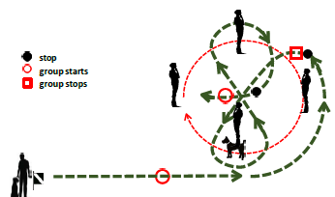

## Heeling

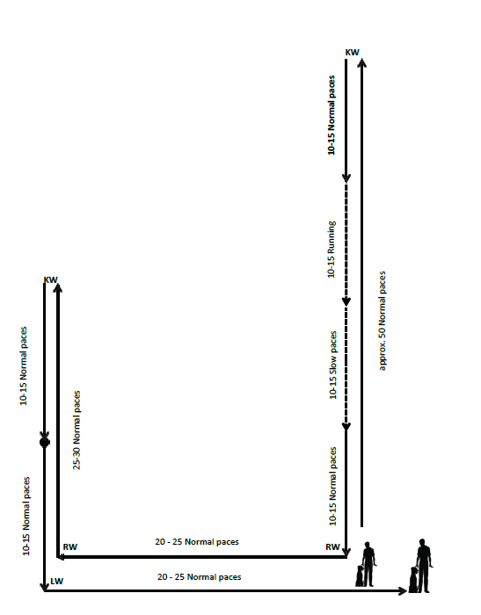

You may use either an auditory or a visual command to begin. The judge will tell you when to start. You do everything else, such as turns, halt, change of pace, and so on, without direction from the judge or other test coordinator.

For the about turns, you must turn to the left (turning 180 degrees in place). For the dog, there are two allowable variations - the dog turns right and goes behind you, or the dog does a left about turn, pivoting in place.

Start by heeling your dog about 50 steps at a normal pace in a straight line down the middle of the field. There will be two gunshots during this phase of the exercise. After the 50 steps, do a left about turn and then 10-15 steps at a normal pace, 10-15 fast steps at a fast pace, 10-15 steps at a slow pace, and finally 10-15 steps at a normal pace. Do not take intermediate steps between the fast and slow portions. The individual gaits need to be clearly distinguishable.

After completing the final 10-15 normal steps take another couple steps and then do a right turn, go 20-25 steps and do another right turn, go another 25-30 steps, do a left about turn, take an additional 10-15 normal steps and then halt in basic position.

After the halt take another 10-15 normal steps, do a left turn, go back to the centerline (about another 20-25 steps) and halt in basic position.

Evaluation: The judge may deduct points for the following faults, among others:

* forging;
* deviating sideways;
* lagging;
* slow or hesitant sitting;
* submissive behavior of the dog;
* body help;
* lack of concentration by the dog;
* extra commands.

## Distance control

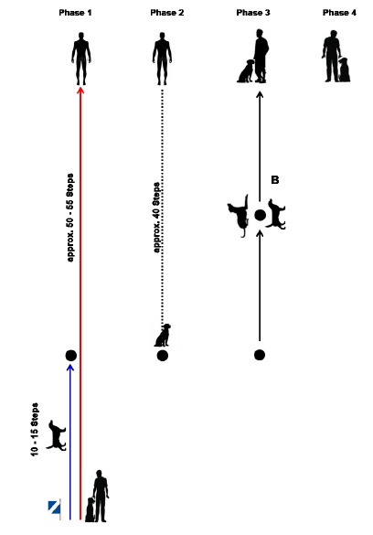

The judge will tell you where to start.

Starting in basic position, when instructed by the judge to begin, after giving the dog an auditory command, heel forward and after 10-15 steps, command the dog to sit with either an auditory or visual command. After an additional 40 steps in a straight line, stop and turn around to face your dog. Call the dog to come with either an auditory or visual command. As the dog reaches half way from where you left it to where you are standing, give an auditory or visual command, or both, for the dog to lay down. Upon the judge's direction, with an audible, visual command, or both have the dog change from a down to a stand. Upon the judge's direction, call the dog to come to the front position with an auditory or visual command. The exercise ends when the dog moves to heel position in response to an auditory or visual command.

Evaluation: The judge may deduct points for the following faults, among others:

* If the distance for the 1st recall and assuming the 2nd position is surpassed by more than 10 steps, the exercise is evaluated with a maximum of satisfactory;
* Positions that are not shown will devalue the score

## Retrieve on the flat

The judge chooses the item all B competitors will retrieve.

Utility articles (something people normally use, not an obedience dumbbell), up to the size of a shoe but no bigger, made of the following materials: wood, leather, light metal, textile, plastic, or a combination of these. Recommendations for the measurement tolerances:  Length 10 – 25 cm, width 5 – 10 cm, thickness 3 – 6 cm. For round articles, the diameter should be about 3 – 6 cm.

It’s important that every dog has the same article to deal with, so do not use articles that can be damaged or deformed by multiple uses. For example, brushes of various types might be damaged during use, so avoid them.

You can use the following articles, among others:

* Shoes, socks, caps, wallets, cell phones
* Pencil case from soft plastic/leather/linen, if possible, filled
* Tool bag from leather/plastic/linen
* Flashlight from plastic/rubber/metal
* Small rolling pin

Do not use these types of articles:

* Glass, porcelain, breakable articles
* Articles under pressure (for example, aerosol cans)
* Articles with liquids
* Tubes, with pastes or similar
* Plastic containers of any kind
* Articles which are too heavy or too light (less than 200 g; more than 500 g) (about 7 oz to a pound)

From the basic position, throw the article about 10 steps away. When the item stops moving, give an auditory or visual command for the retrieve. The dog should briskly go and return to a sit in front. After a brief pause give an auditory or visual command to release. Give an auditory or visual command to return to the basic position. That ends the exercise.

Evaluation: The judge may deduct points for the following faults, among others:

* slow or indirect to the article;
* mistake when picking up;
* slow or not indirect coming back;
* dropping the article;
* playing or mouthing the article;
* Throwing the article too short or too far or helping the dog;
* If you change your location the exercise receives 0 points;
* If the dog does not retrieve, the exercise receives 0 points.

Carry and hand over

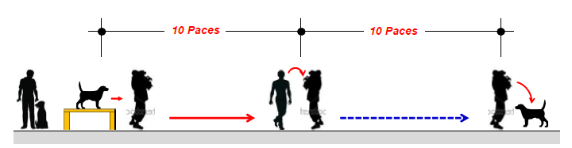

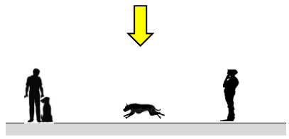

From the basic position give an auditory, visual command or both for the dog to jump onto the table. Carry the dog 10 steps then hand him over to the assistant. Remain in place while the assistant carries the dog 10 steps further. After the assistant puts the dog down, he should remain with the assistant until the judge directs you to call the dog to front with an auditory or visual command. The exercise ends when you give an auditory or visual command to for the dog to return to the basic position. During the carry, the dog's tail should be outside the arm holding the dog.

You should be able to carry your dog. If you can’t, the assistant will pick the dog up from the table, and carry the dog 10 steps with you walking alongside the assistant. After 10 paces you stop while a second assistant carries the dog another 10 paces. The exercise proceeds as above.

Evaluation: The judge may deduct points if the dog

* is not cooperative;
* is not calm during the carry;
* growls slightly or pulls back when picked up or put down;
* leaves the assistant after having been put down.

If the dog jumps out of the assistant’s arms during the carry, the exercise will be scored as insufficient.

## Directability at a distance

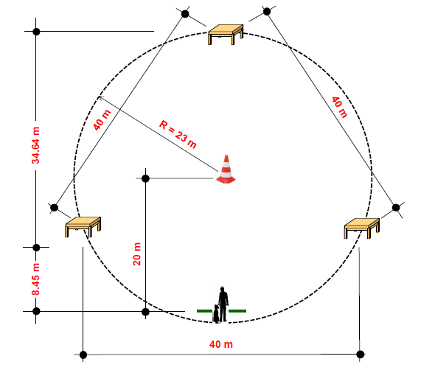

The sequence in which you will send the dog to the table is determined by the earlier draw. At the center marker and each table, the dog must remain for three seconds before being commanded to proceed.

From the basic position and at the judge's cue to begin, give an auditory, visual command, or both, for the dog to go to the center marker. When the dog has arrived, give an auditory, visual command, or both for the dog to remain in place. The directability exercise does not require a specific position (sit, stand, down) for the dog to wait at either the center marker or the tables. You may give your dog a specific position command or may give your dog a less specific ‘stay’ or ‘wait’. After the pause, start sending the dog to the three tables in the order you announced to the judge at the beginning of the exercise. At each directional send to a table you can give one auditory or visual command or both, for the dog to go to the table and one auditory command to jump onto and remain on the table. For some handlers this might be “left”, “table”. For other handlers this might be “jump”, “wait”. Any variation is possible but there is one auditory or visual command, or both, to go to a table and a second auditory command to jump onto then remain on the table.

Send the dog to the three tables in turn, using commands as discussed in the last paragraph. You may turn (pivot in place) or take a small lateral step toward the table you are sending the dog to, or both, without being considered to have left the designated area. The dog must stay at each table at least 3 seconds before you send him to the next table. From the final table, after the pause, give an auditory or visual command to come to front. End the exercise ends with an auditory or visual command for the dog to move to basic position.

If the dog does not stop in the middle, if the sequence the dog does not follow the sequence you specified at the beginning of the exercise, or if you leave your location, the exercise is considered insufficient.

Evaluation: The judge may deduct points if the dog

* hesitates to run to the tables or the center marker;
* strongly deviates from the ideal line;
* hesitates to jump on the tables;
* prematurely leaves a table or the center marker;
* hesitates to assume a position;
* is slow in the recall or front sit;
* receives handler aids such as repeated auditory commands;
* makes mistakes in the finish.

## Swing

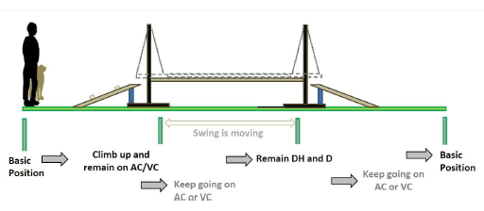

From the basic position, and on the command of the judge, with either an auditory or visual command, or both, tell the dog to mount the movable plank via the mounting ramp. Once the dog has jumped on the plank, give an auditory command to the dog to remain in place facing in the direction of travel. The swing does not require a specific position (sit, stand, down) for the dog to wait. You may give your dog a specific position command or may give your dog a less specific ‘stay’ or ‘wait’. When the judge tells you to go to the dog, move to the dog’s side and then give the dog an auditory or visual command to move forward to the end of the plank. The dog must independently wait at the end of the plank. At the instruction of the judge, command the dog with an auditory or visual command to continue forward to leave the apparatus via the dismounting ramp then several steps beyond. End the exercise by halting. Your dog should independently assume the basic position, as in normal heeling.

The dog has to go the entire length of the apparatus without fear, being erratic, being anxious, or being hectic.

Evaluation: The judge may deduct points for the following faults, among others;

* hesitant or hectic mounting;
* the dog is insecure or hesitant in moving across the apparatus;
* hesitantly assuming a waiting position or basic position.

## If the dog jumps off within the first half of the apparatus, the exercise is scored with 0 points.

## If the dog jumps off after the first half, the exercise is considered insufficient.

## Ladder

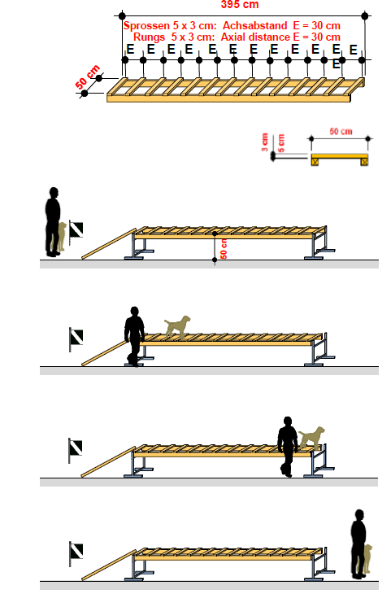

From the basic position in front of the ladder, give an auditory or visual command, or both, for the dog to go up the ramp, proceed to the last rung, and remain there. Once the dog has reached the first rung with his front paws, walk alongside the dog. When the dog has reached the end of the ladder, lift him off and give him an auditory or visual command to assume the basic position.

## Tunnel with tube

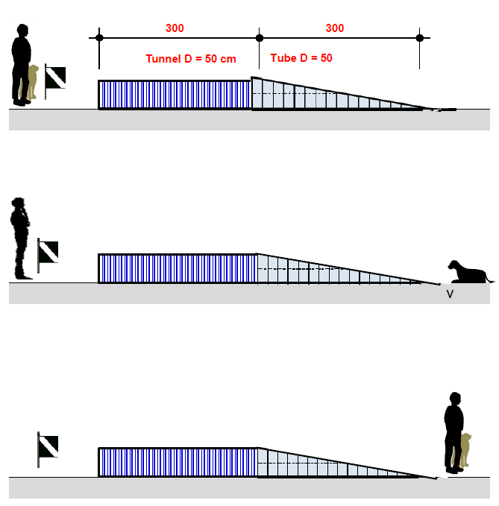

Beginning in basic position, on the command of the judge, command the dog with either an auditory or visual command, or both, to move through the tunnel. Once the dog has left the tunnel give an auditory or visual command to stay. The tunnel does not require a specific position (sit, stand, down) for the dog to wait. You may give your dog a specific position command or may give your dog a less specific ‘stay’ or ‘wait’. At the instruction of the judge, go to the dog and with an auditory or visual command, or both, to tell the dog to move to the basic position.

Evaluation: The judge may deduct points if the dog is insecure or hesitant going through the tunnel. If the dog does not leave the tunnel, or does not stay on command after leaving the tunnel, the exercise will be scored as insufficient. The judge may also deduct points for extra commands or body help.

## Down under distraction

Before the start of the work, one location for male dogs and another for female dogs will be marked on the field.

When instructed by the judge, go to the appropriate spot and take a basic position. Before the other (working) team begins the heeling exercise, take off your leash. When instructed by the judge, tell your dog to lie down, using either an auditory or visual command, then move to a spot about 40 steps away behind a screen of some sort on the field, as indicated by the judge. At the end of the other (working) team’s heeling, go independently to be a walking person in the group. When that exercise is finished, return to the original place the judge told you to stand.

Upon instruction of the judge, give either an auditory or visual command for the dog to assume the basic position.

Evaluation: The judge may deduct points if the dog

* does not lie down when instructed;
* is restless or distracted in the down;
* leaves the down position;
* stands or sits up prematurely;
* approaches approach you when you return to the dog.

The judge may also deduct points for extra commands or body aids.

If the dog leaves the down place by more than 3 meters

* after the end of exercise 2 of the working dog, the exercise is insufficient;
* before the end of exercise 2 of the working dog, the exercise is scored with 0 points

If the dog stands or sits instead of downing, but remains within the down area, the exercise is devalued by 5 points.

1. These notes are provided to help exhibitors and trainers but do not replace the official rules. All the information in this document, including sketches, is drawn from the International Trial Rules for Rescue Dog Tests of the Fédération Cynologique Internationale (FCI) and the International Rescue Dog Organisation (IRO), 2025. Brackets – [ ] – indicate abbreviations used in the FCI/IRO rules.