# RH Tracking (F) V title information

# **General information[1]**

Dogs must be 15 months old to enter this test.

This section applies to all exercises at all levels, unless otherwise noted.

To attain the full title - IPO-R FL V – the dog-handler team must pass both the obedience-dexterity phase with at least 70 points (out of 100) and the scent work phase with at least 70 points (out of 100). A team need only pass this test once to earn the title and be eligible for the next level. If the team fails one phase (obedience/dexterity or scent work) they must attempt the other phase unless they are excused. It is up to the judge and trial logistics which phase is attempted first. On a multi-day trial, each phase need not occur on the same day. The team need not attain a minimum score on any single obedience-dexterity exercise; that is, they can fail a single exercise and still pass if they earn enough points in other obedience-dexterity exercises.

Behavior of the dog handler (you)[DH]: The judge will consider your behavior, team work with the dog, and sportsmanship.

Behavior of the dog [D]: The judge will consider the dog’s joy to work, handling, responsiveness to commands, mobility, fitness, endurance and the overall picture. The dog should carry out the exercises happily and quickly.

Rewards: You may praise your dog briefly after an exercise ends. You are not allowed to carry or provide food or toys to the dog in either phase.

Heeling: During heeling, the dog should have a natural gait. The dog should be at your knee, and should be attentive, happy, close, and straight. When you stop, the dog should sit without a verbal or visual command, and be close and straight.

Auditory command [AC] and visual command [VC]: For some exercises both an auditory and visual command is allowed. You can choose to give just auditory or just visual. If you tell the judge in advance, you can use a whistle as an auditory command. Any visual or auditory command must be short. If you use both you must use them simultaneously. The name of the dog is considered an auditory command. If the dog requires a second command to execute an exercise or part of an exercise, the team will be penalized. If the dog does not execute the command after a third command, the exercise is terminated and you receive a 0. If the dog refuses to execute an apparatus or search an area, you will get a 0 for the exercise. You may not repeat an obstacle or area. You should pause 3 seconds between commands. Non-use of auditory or visual commands are not considered faulty.

Obstacles: Unless told differently from the judge, each dexterity obstacle begins set up in heel position two steps before the obstacle and ends beyond it.

You can choose any commands. They can be in any language, including a mix of languages.

# **Scent work**

The track is laid by you with your own articles. The length is 400 normal steps, with two 90 degree turns. Three articles are to be placed on the track. The first article is placed on the first leg; the second article is on the second leg; the third article is at the end of the third leg. The track is aged 20 minutes. The dog must complete the track in 15 minutes. The dog can miss one or more articles and still pass if the team earns enough points in other aspects of this phase.

The dog can be tracked on a collar or harness with a 10 meter leash. Alternatively, the dog can track off leash where you follow 10 meters behind.

Before to beginning you will tell the judge if the dog will retrieve or indicate the articles. If the dog retrieves, the dog can be restarted where the article was delivered or where the article was found. If the dog indicates, the position can be a sit, stand, or down.

Slight deviations from the track are not faulty as long as the dog independently follows the continuation of the track. The dog should show an independent and happy track work with a confident and independent indication of the articles.

Articles should be well scented "utility" (i.e. things a lost person might drop like a hat, flashlight, or key ring) made of any material, maximum sneaker size, and the color should not stand out markedly in the terrain. Toys are not permissible articles.

As a separate exercise, the dog must demonstrate an alert on a victim. The options are

- bark at the victim

- bringsel

- free indication (find-refind)

- indication (dog does a sit, stand, or down at the victim)

You inform the judge of the alert style. The victim is visible to the dog and is sitting or lying down 30 meters away. While you stay with the judge, the dog is to go directly to the victim and immediately alert.

From the alert, you have two options

* Move yourself a few feet from the victim, call the dog to you, and command the dog to stay; or

* Go to the dog in heel position, heel the dog a few feet from the victim, and command the dog to stay.

Once the dog is stabilized, go and check on the victim.

Maintaining the Track: 50 points

Articles, 3 x 10 points: 30 points

Alert exercise: 20 points

# **Obedience/dexterity**

Two teams enter the field at the same time.

## Reporting in

The first exercise involves both teams - reporting in and social behavior. When called, both dog-handler teams, on leash, go to the designated place for a microchip check. One of the dog-handler teams takes on the role of the "group" dog and the other as the "working" dog. Once the "working" dog has completed the following, the roles switch and the exercise is repeated.

The group consists of three people and the "group" dog-handler team. These four move clockwise and the "working" dog-handler team circle them counter-clockwise. Once the "working" dog-handler team has passed everyone once they halt and the group of four continue walking until the judge's instruction. The "working" dog-handler team then performs a figure 8 with the inside circle around the "group" dog-handler team (that is, move counter clockwise around the other dog-handler team so the dogs are near one another without a handler between) and an outside (clockwise circle) around one other person, ending in the center of the group. The group of four move again on the judge's signal and the "working" dog-handler team exists the group. Now the roles switch and the exercise is repeated. Once both dog-handler teams have played both roles, on leash, one team goes to begin the heeling and the other goes to the long down area.

The handler may give one auditory or visual command for the check of the microchip and one auditory or visual command for each start of heeling.

Evaluation: You dog should be social or neutral towards the other dog. If your dog shows aggression and attacks a dog in the group, you will be disqualified. The judge may also deduct points for the following faults, among others:

* lack of concentration by the dog;
* extra commands.

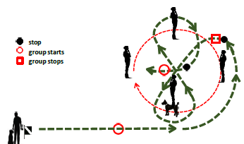

## On leash heeling

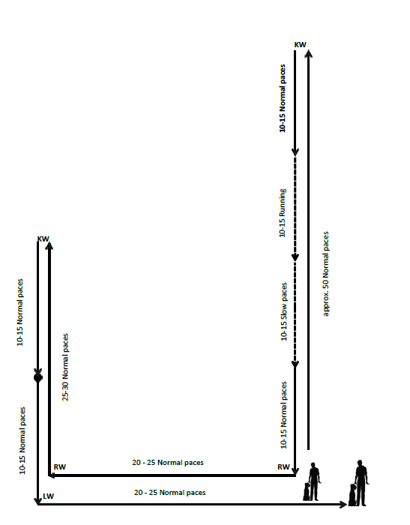

The exercise is done with your dog on leash. You may use either an auditory or a visual command; you may also give an auditory or visual command at each change of pace. The judge will tell you when to start. You do everything else, such as turns, halt, change of pace, and so on, without direction from the judge or other test coordinator.

Start by heeling your dog about 50 steps at a normal pace in a straight line down the middle of the field. After the 50 steps, do a left about turn and then 10-15 steps at a normal pace, 10-15 fast steps at a fast pace, 10-15 steps at a slow pace, and finally 10-15 steps at a normal pace. You are permitted to repeat the auditory command to heel at each change of pace. Do not take intermediate steps between the fast and slow portions. The individual gaits need to be clearly distinguishable.

After completing the final 10-15 normal steps take another couple steps and then do a right turn, go 20-25 steps and do another right turn, go another 25-30 steps, do a left about turn, take an additional 10-15 normal steps and then halt in basic position.

After the halt take another additional 10-15 normal steps, do a left turn, go back to the centerline (about another 20-25 steps) and halt in basic position.

For the about turn, you must turn to the left (turning 180 degrees in place). For the dog, there are two allowable variations - the dog turns right and goes behind you, or the dog does a left about turn, pivoting in place.

Evaluation: The judge may deduct points for the following faults, among others:

* forging;
* deviating sideways;
* lagging;
* slow or hesitant sitting;
* straining on the leash;
* submissive behavior of the dog;
* extra commands;
* body help.

## Sit in motion with recall

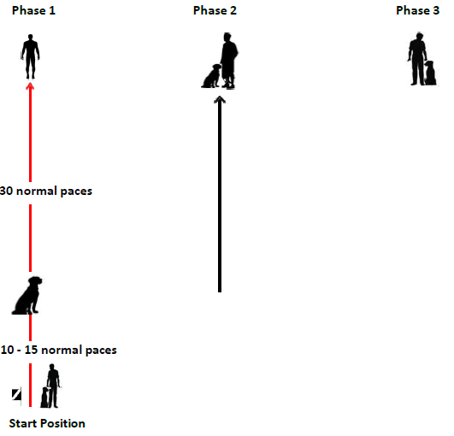

The judge will tell you where to start.

You may give one auditory or visible command for each - to begin heeling, for the dog to sit, for the dog to come, and for the dog to go into basic position.

Starting in basic position, when instructed by the judge to begin, heel with your off-leash dog straight down the field. After 10-15 steps, give the dog a command to sit. The dog should sit in the same direction you have been heeling. You should continue down the field without looking back at the dog or breaking stride for another 30 steps or so. Stop and turn to face the dog.

When instructed by the judge, call your dog. After a pause of 3 seconds, tell the dog to go into basic position.

Evaluation: The judge may deduct points for the following faults, among others:

* mistakes in the development;
* slow sit;
* unsteady sit;
* slow recall;
* crooked front or finish;
* extra commands or body aids.

Change of Position

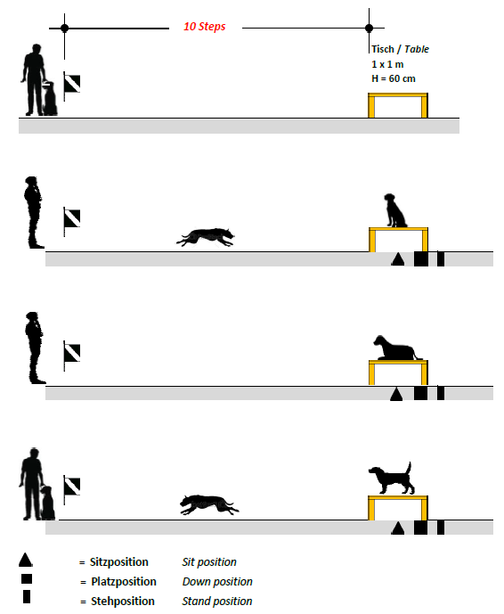

Begin 10 steps from the table. On the judge’s command, send the dog to the table with an auditory or visual command or both. The dog should jump without hesitation on the table and remain there. At the judge’s instruction, demonstrate sit-down-stand using an auditory, visual command, or both for each position change. At the judge’s command, recall the dog to the front position with either an auditory or visual command. Then, with an auditory or visual command, the dog should assume the basic position.

Evaluation: The judge may deduct points for the following faults, among others:

* hesitant mounting the table;
* slow to take a position;
* failure to take a position;
* slow recall;
* crooked front or finish;
* extra commands or body aids.

Carry and hand over

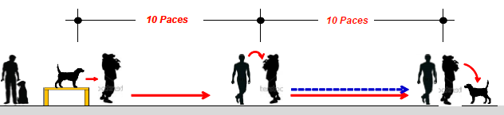

At the judge’s command, from the basic position and quite close to the table (see diagram) send the dog to the table with either an auditory or visual command or both. Pick the dog up, ensuring the tail is free, then carry him 10 steps straight on and hand him over to an assistant, who carries him another 10 steps and then sets him down. You walk alongside the assistant as he carries your dog. You can speak to your dog while he is being carried.

You should be able to carry your dog. If you can’t, the assistant will pick the dog up from the table, and carry the dog 10 steps and transfer to a second assistant while you walk alongside this second assistant. Once the dog is put down, call the dog to basic position with either an auditory or visible command. Evaluation: The judge may deduct points if the dog

* is not cooperative;
* is not calm during the carry;
* growls slightly or pulls back when picked up or put down;
* leaves the assistant after having been put down.

If the dog jumps out of the assistant’s arms during the carry, the exercise will be scored as insufficient.

# Directability at distance

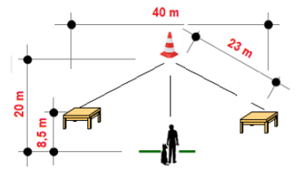

At the beginning of the exercise, announce the sequence in which you will send the dog to the tables. At the center marker and each table, the dog must remain for three seconds before being commanded to proceed.

From the basic position and at the judge's cue to begin, give an auditory, visual command, or both, for the dog to go to the center marker. When the dog has arrived, give an auditory, visual command, or both for the dog to remain in place. The directability exercise does not require a specific position (sit, stand, down) for the dog to wait at either the center marker or on the tables. You may give your dog a specific position command or may give your dog a less specific ‘stay’ or ‘wait’. After the pause, send the dog to the two tables in the order you announced to the judge at the beginning of the exercise with a pause at the first table before sending to the second table. At each directional send to a table you can give one auditory or visual command or both, for the dog to go to the table and one auditory, visual command, or both, to jump onto and remain on the table. For some handlers this might be “left”, “table”. For other handlers this might be “jump”, “wait”.

When you send the dog to a tables you may turn (pivot in place) or take a small lateral step toward the table you are sending the dog to, or both, without being considered to have left the designated area. The dog must stay at each table at least 3 seconds before you send him to the next table. From the final table, after the pause, give an auditory or visual command to come to front. End the exercise ends with an auditory or visual command for the dog to move to basic position.

If the dog does not stop in the middle, if the sequence the dog does not follow the sequence you specified at the beginning of the exercise, or if you leave your location, the exercise is considered insufficient.

Evaluation: The judge may deduct points if the dog

* hesitates to run to the tables or the center marker;
* strongly deviates from the ideal line;
* hesitates to jump on the tables;
* prematurely leaves a table or the center marker;
* hesitates to assume a position;
* is slow in the recall or front sit;
* receives handler aids such as repeated auditory commands;
* makes mistakes in the finish.

## Tunnel with tube

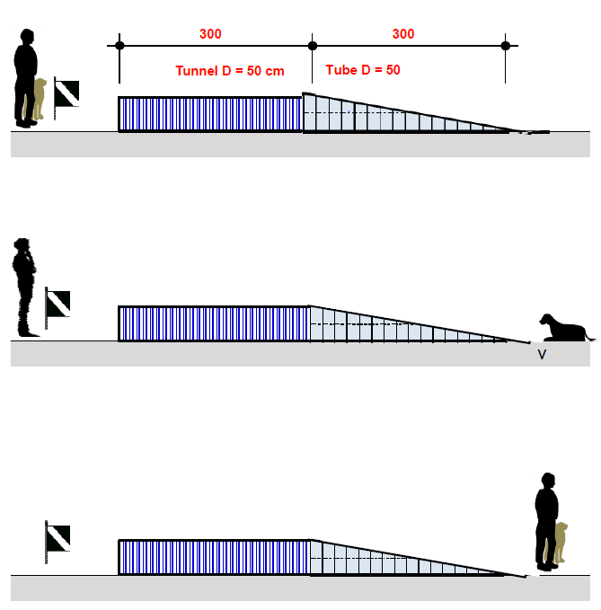

Beginning in basic position, on the command of the judge, command the dog with either an auditory or visual command or both to move through the tunnel. Once the dog has left the tunnel give an auditory or visual command to stay. At the instruction of the judge, go to the dog and with an auditory or visual command tell the dog to move to the basic position.

Evaluation: The judge may deduct points if the dog is insecure or hesitant going through the tunnel. If the dog does not leave the tunnel, or does not stay on command after leaving the tunnel, the exercise will be scored as insufficient. The judge may also deduct points for extra commands or body help.

## Traversing an elevated rigid wooden board

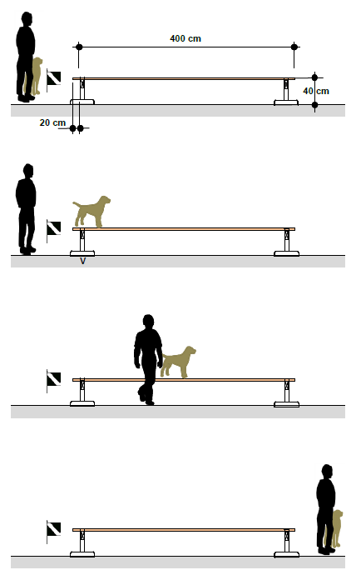

From the basic position, and on the command of the judge, with either an auditory, visual command, or both tell the dog to mount the obstacle then with an auditory command tell the dog to stop immediately, facing in the direction of travel. Upon the judge’s command, go to the side of the dog, give an auditory or visible command for the dog to continue along then off the obstacle and stop in the basic position. The dog has to go the entire length of the wooden board without any fear or being erratic.

Evaluation: The judge may deduct points for the following faults, among others;

* the dog is insecure or hesitant in moving across the board;
* the dog runs ahead of or lags behind the handler;
* extra commands or body help.

If the dog jumps off the board within the first half, the exercise is scored a zero.

## Down under distraction

Before the start of the work, one location for male dogs and another for female dogs will be marked on the field. Also marked will be a position 20 steps from the dog where you are to wait.

After having completed the exercise “Reporting in and social behavior” and prior to the other dog team beginning the heeling pattern, the down stay handler goes to the marked place, removes the leash, and at the instruction of the judge, commands the dog to lie down with an auditory or visible command and goes to the waiting place.

When the other (working) team completes the change of position, and when instructed by the judge to return, the handler stands in heel position. On another signal from the judge the handler commands the dog to sit with either an auditory or visible command. You may now leash the dog. You are to wait in the down area or other area indicated while the other team completes their routine.

Evaluation: The judge may deduct points if the dog

* does not lie down when instructed;
* is restless or distracted in the down;
* leaves the down position;
* stands or sits up prematurely;
* approaches the handler when the handler returns to the dog.

The judge may also deduct points for extra commands or body aids.

If the dog leaves the down place by more than 3 meters

* after the end of exercise 2 of the working dog, the exercise is insufficient;
* before the end of exercise 2 of the working dog, the exercise is scored with 0 points

If the dog stands or sits instead of downing, but remains within the down area, the exercise is devalued by 5 points.

1. These notes are provided to help exhibitors and trainers but do not replace the official rules. All the information in this document, including sketches, is drawn from the International Trial Rules For Rescue Dog Tests of the Fédération Cynologique Internationale (FCI) and the International Rescue Dog Organisation (IRO), 2025. Brackets – [ ] – indicate abbreviations used in the FCI/IRO rules.